DATABASE ASSESSMENT BY 23019446

IDEA Home Furniture report

Link to Site: <https://www.teach.scam.keele.ac.uk/prin/x9j25/DatabaseAssessment/LoginD.php>

Password to Login as administrator is admin the Username is also admin

Password to Login as consumer is consumer the Username is also consumer

Functional requirements

A sizable database was needed by IDEA Home Furnishings to hold the information about every one of its home furnishings goods. Owing to their substantial inventory, they had to dispatch certain items for delivery or pickup at the store. I achieved this by opening various locations around the nation, each with a number of staff members who processed orders for online delivery and/or pickup. Every store has a minimum of one supplier who provides goods to one or more stores. Many workers are employed by every store to handle the merchandise for pickup and delivery. Every client has a unique account that they may use to access their webpage, which the business keeps on file for future usage. Customers can see previously selected products. This also stores all the previous purchase searches that customers have made. The company added this feature for marketing purposes. Added ability to search supplier, consumer, store, employee, delivery, collection, collection employee, delivery employee and purchase for administrators. I also added access to guests but it is not saved.

Design and Implementation

Conceptual ERD

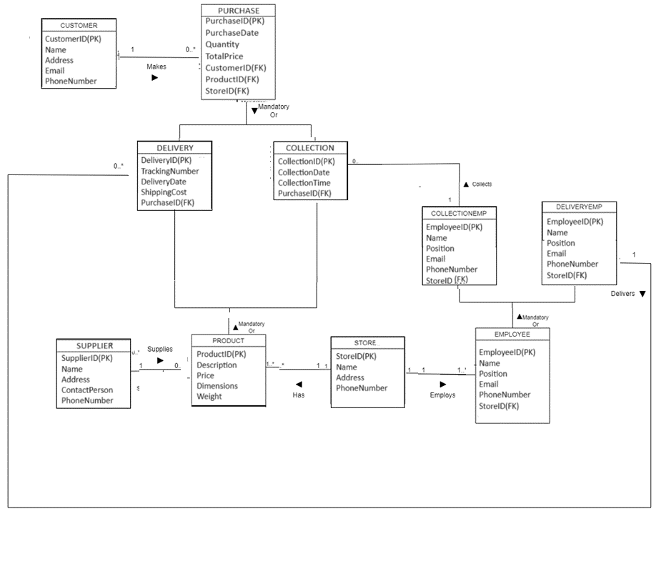

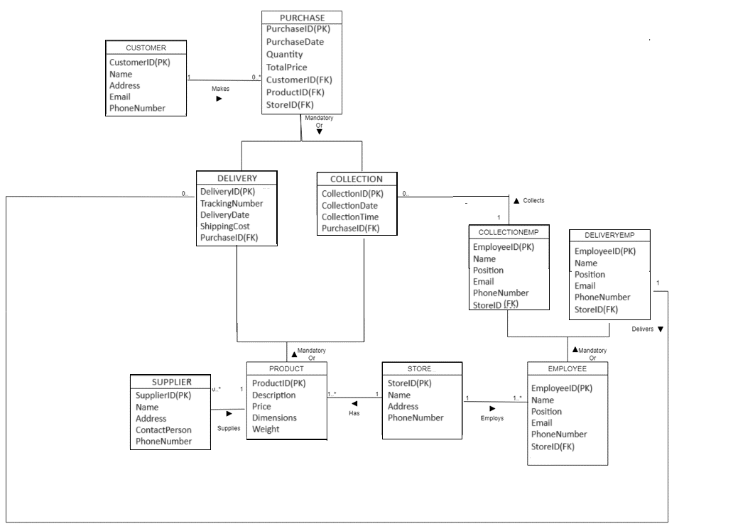

**Logical ERD**

Given that IDEA Home Furnishings had numerous locations across the nation, I made the decision to make tables for their store in accordance with their specifications. In my conceptual ERD, I constructed a 1..* to 0..* range since I believed that at least one store could supply zero or many products to each of their individual stores. I also created a supplier table and a product table.

Secondly, I created a 1 to 1..* link between the store and employee table in my ERDs because without employees, the businesses could not operate. I made a webpage for a particular search that shows the workers along with the business and industry they work in. The retail staff were also given a job sector, delivery or collection in this example. The products can be picked up in-store or delivered, depending on their weight and dimensions. I created subclasses based on the weight and dimensions of the employee jobs and the sequence in which they were processed. After they processed the order, the employees would then deliver the order or pick it up for collection depending on the purchase.

Customers can place as many orders as they'd like at the customer and purchase table I made. The personal information of the clients was presented in the customer table. I made a purchasing order table that displays the customer's account number, ID, and the product they bought in order to allow customers to place orders and for the business to keep track of past transactions. Since I believed that a single client could place one or more orders, I created a 1 to 0..* link between the customer and the purchase table. Customers were given accounts within the purchase table, allowing the business to keep track of what each customer had ordered. This is what I had on one of the website's pages. To reveal exactly what product, they ordered in the past, I made a web page that displays this. I achieved this by making a link between the purchases table and product table using a foreign key. This new table reveals when they made the orders and exactly what product has been ordered.

Application Features

To summarize the characteristics of the website, I designed a multi-layer webpage that provided several search options. Through the application's login feature, users may examine items and corporate administrators can check which fields are required. Password to Login as administrator is admin the username is also admin the password to login as consumer is consumer the username is also consumer. A more comprehensive search option that retrieves all created tables and their individual entries was included on the administration page. The other website concentrated more on customer-specific entries. My application essentially used a search menu to let the user select the table or record they wanted to examine for the searches. There is also a submit button to activate the search and a message at the bottom of the table to warn the user if no query has been selected.